Sunny Bhatoa
CS 340

Project Two Dashboard – Grazioso Salvare

Overview
This dashboard was developed using Python, Dash, and MongoDB to support Grazioso Salvare in identifying dogs suitable for different rescue operations. The application provides an interactive interface that allows users to filter animals based on rescue type and visualize results dynamically.

Functionality
The dashboard includes the following features:
- Interactive Data Table
  - Displays all animal records from the database
  - Updates dynamically based on selected filters
- Filter Controls
  - Reset (all data)
  - Water Rescue
  - Mountain or Wilderness Rescue
  - Disaster or Individual Tracking
- Dynamic Chart
  - Pie chart showing distribution of breeds
  - Updates based on filtered data
- Geolocation Map
  - Displays selected animal’s location
  - Updates when a row is clicked
  - Shows breed and animal name in popup

Screenshots
  - Reset (All Data)
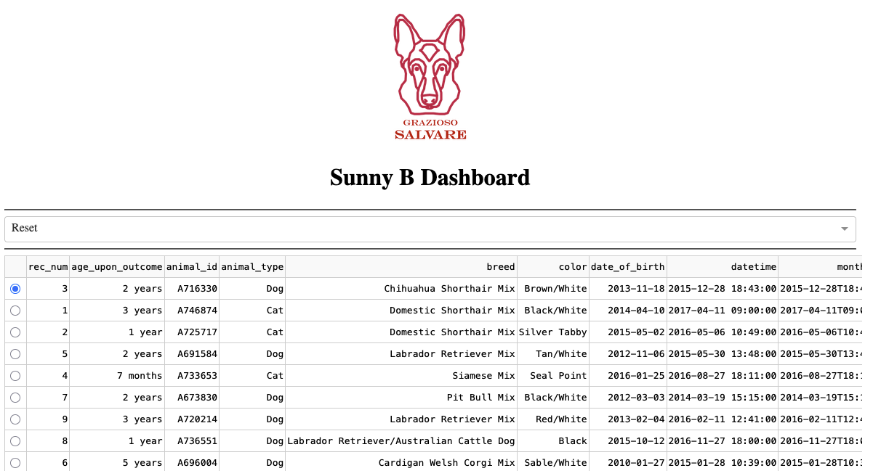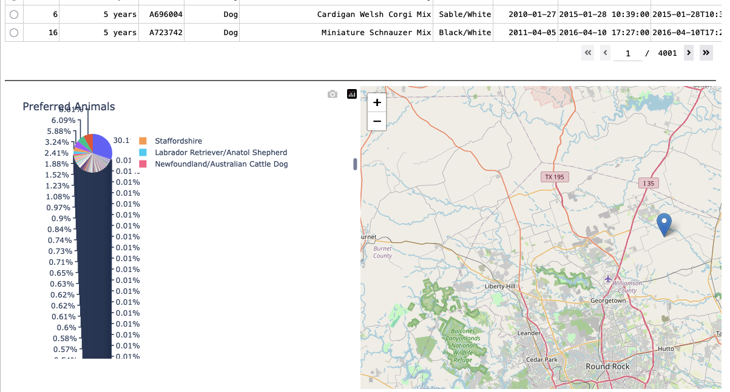

  - Water Rescue Filter
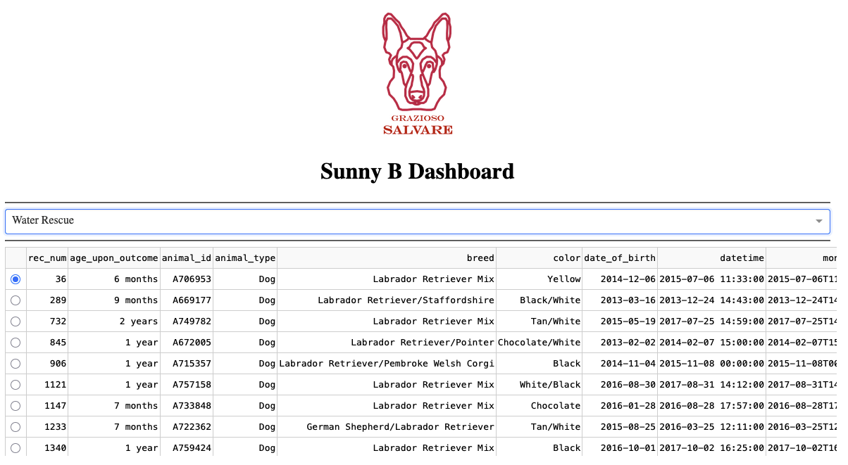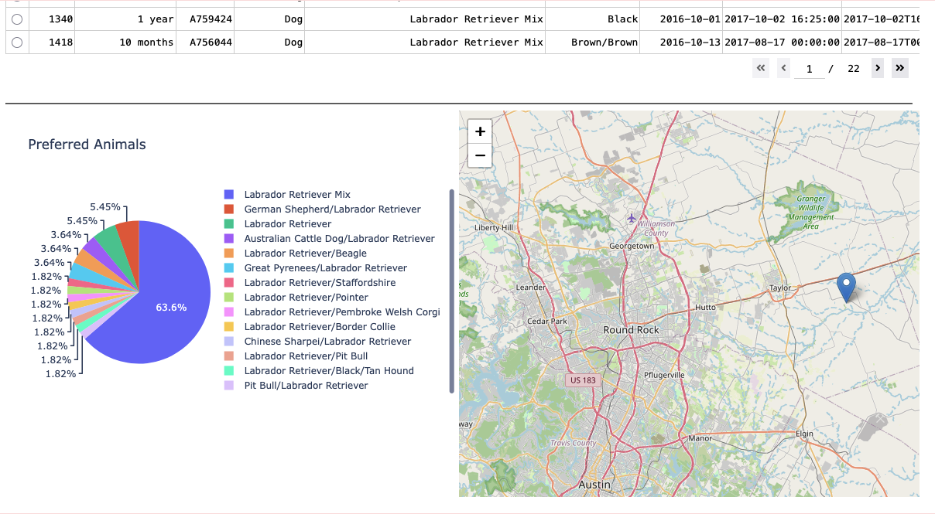

  - Mountain or Wilderness Rescue Filter
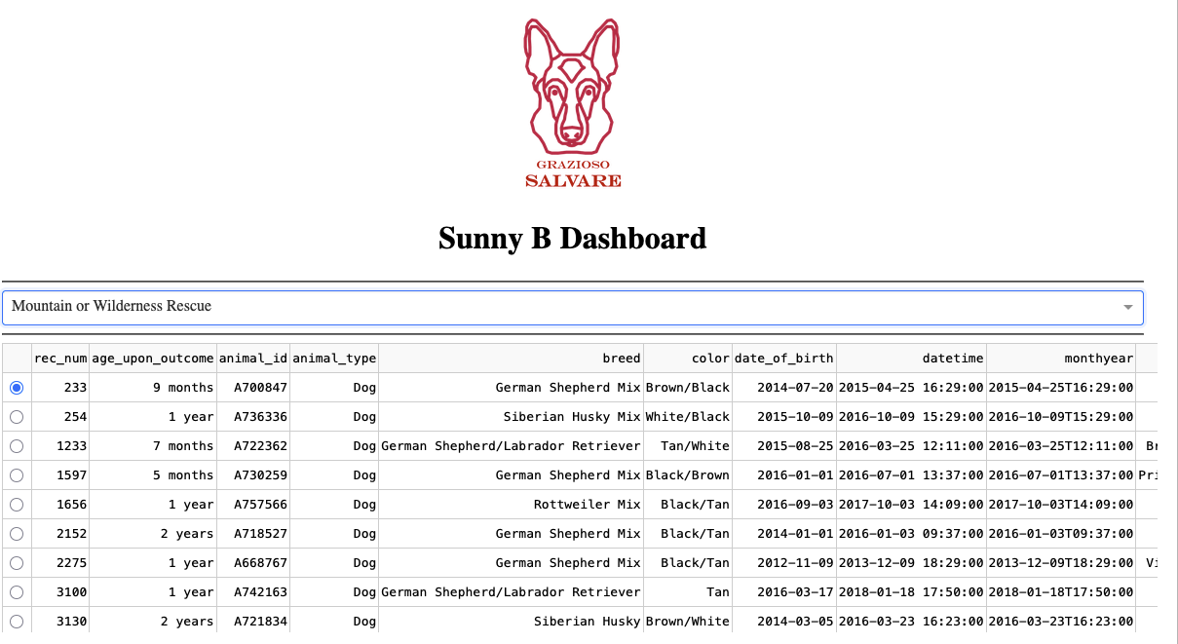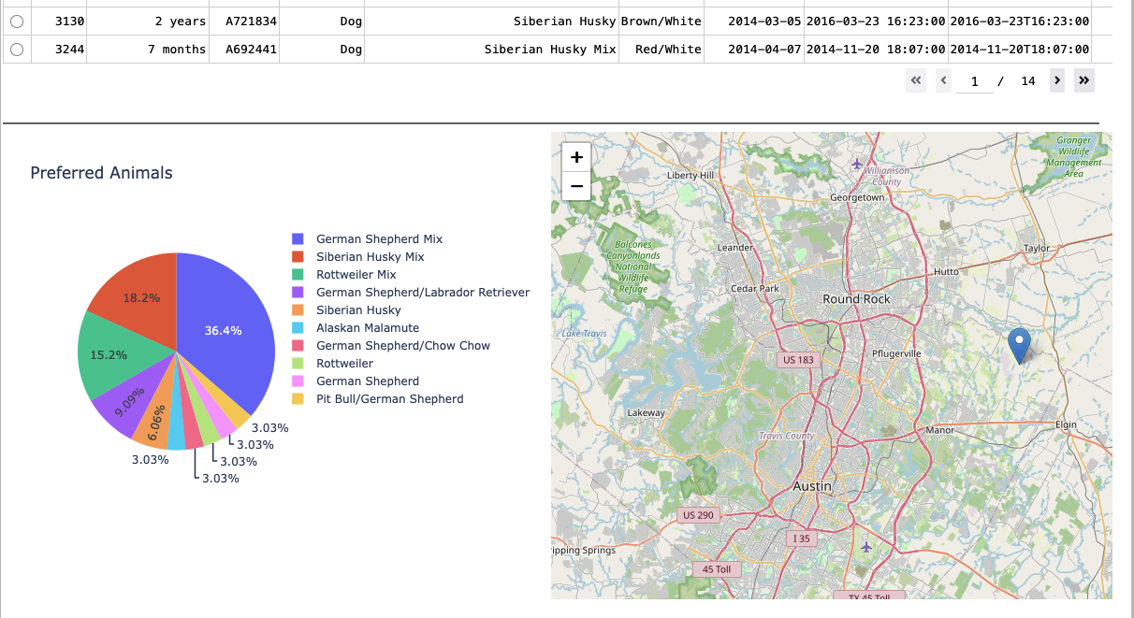

  - Disaster or Individual Tracking Filter
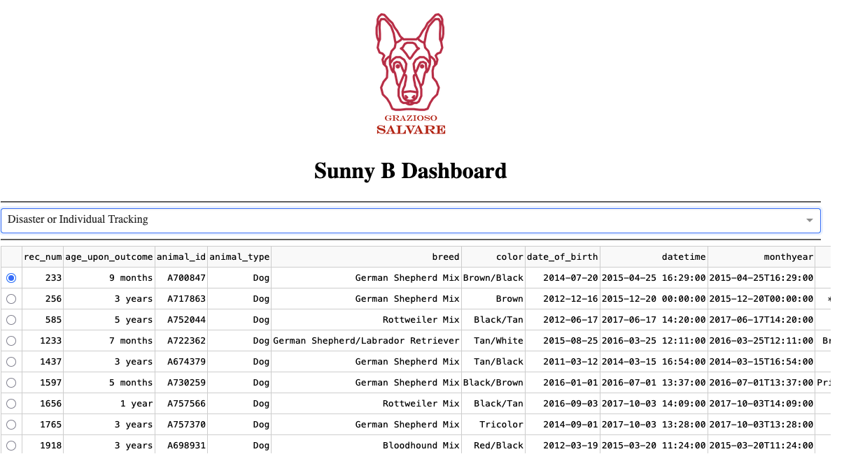
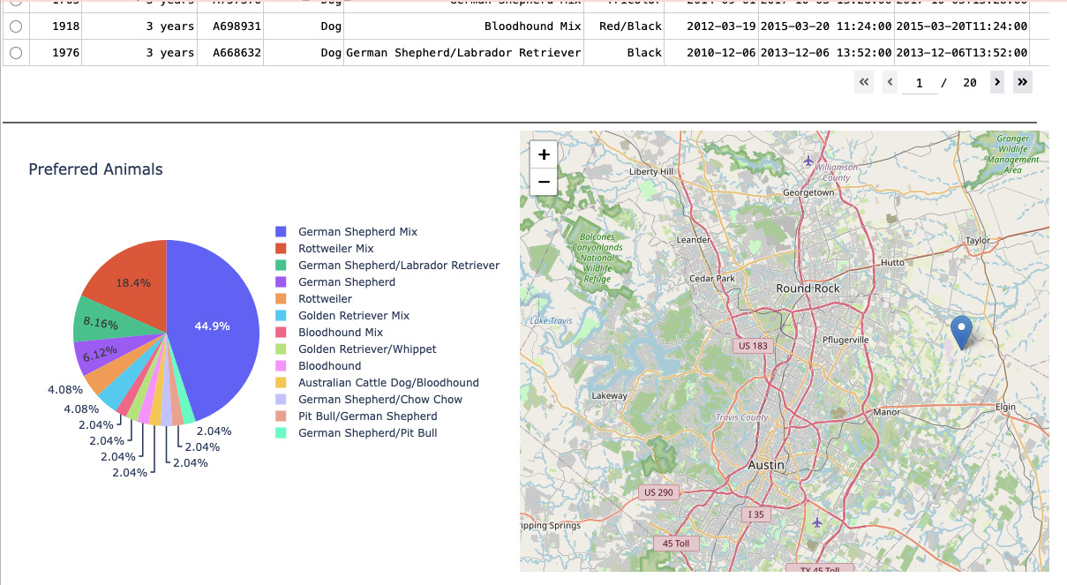

  - Interactive Map Selection
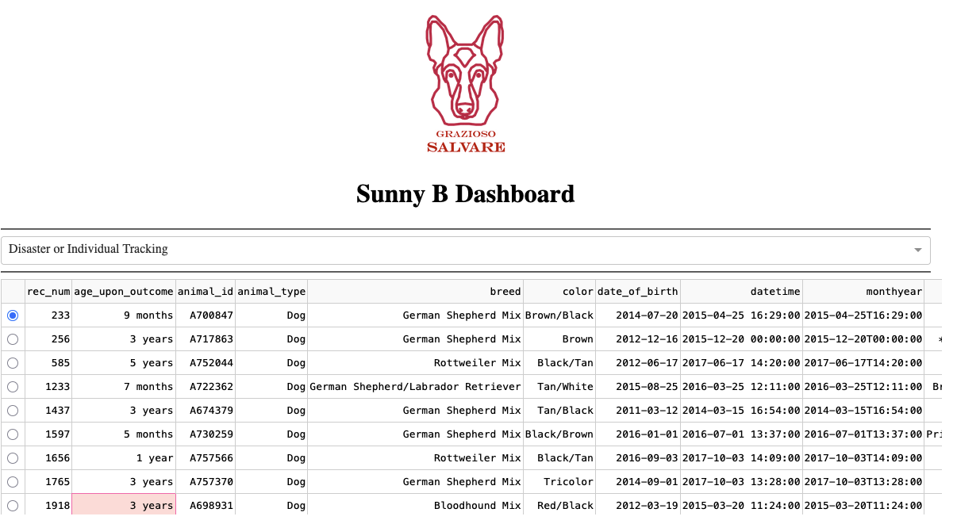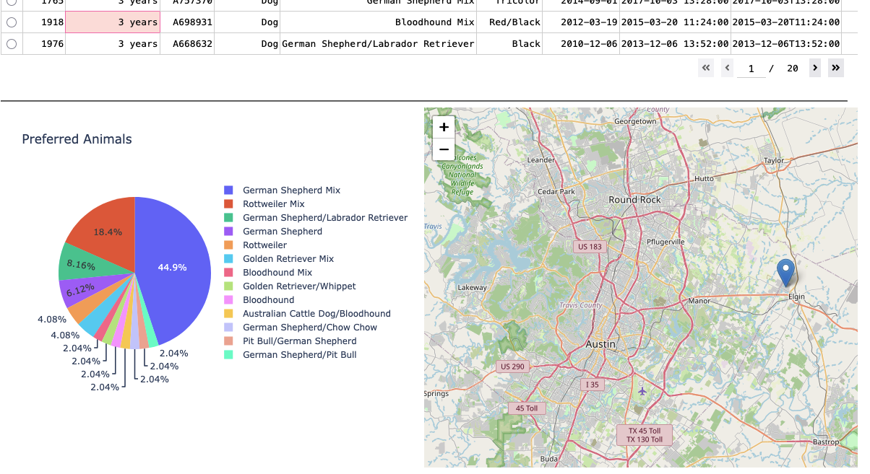

Tools Used
- Python
  - Core programming language used to build the application
- Dash
  - Used to create the interactive web dashboard
  - Handles UI components and callbacks
- MongoDB
  - Stores animal data
  - Allows flexible querying for filtering
- Plotly
  - Used to create dynamic visualizations (pie chart)
- Dash Leaflet
  - Used to create the geolocation map

How to Run the Project
- Open the Jupyter Notebook in Codio or JupyterLab
- Run all cells in order
- Ensure MongoDB is running locally
- Run the final cell:
app.run_server(mode="inline", debug=False)
- The dashboard will appear in the notebook output

Testing and Interaction
- Select different filters from the dropdown
- Observe:
  - Table updates
  - Chart updates
- Click any row in the table:
  - Map updates
  - Popup shows animal name

Challenges and Solutions
- Issue: Dashboard not loading due to JupyterDash configuration
Solution: Added JupyterDash.infer_jupyter_proxy_config() for compatibility
- Issue: Map not updating
Solution: Used active_cell to track row selection
- Issue: Kernel freezing
Solution: Restarted kernel and reran all cells

